**Internship Completion Report**

**~29th May,23** to **28th July,23**

**Brief Introduction of all three interns**

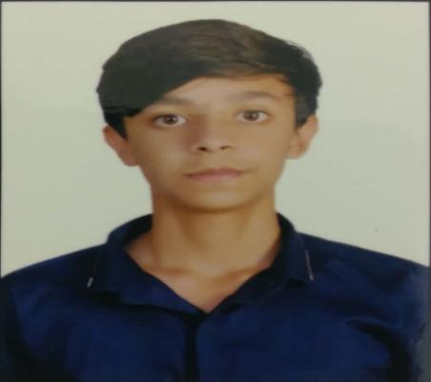

**Name:** Rohan Sakkarwal **Age:** 20 years

~ I am a **4th year student** pursuing **bachelor’s in technology** in **Computer Engineering** from **Delhi Technological University**.

~ Recruited by **Siemens** as an **intern** from my college internship program for a period of **2 months** (29th May to 28th July).

~ I have good hands in **Coding** and have **Knowledge** about

* C++
* JAVA
* Object Oriented Programming (OOPS)
* Database Management System (DBMS)
* SQL
* XML, JSON etc.
* Web Development

~ Besides my technical background,

* I am a **National Level Basketball player** and good in sports like **cricket** and **badminton**.
* I am **good at dancing** and won street battles and am also the member of my dance society.
* I hold an **orange belt** in **Taekwondo**.

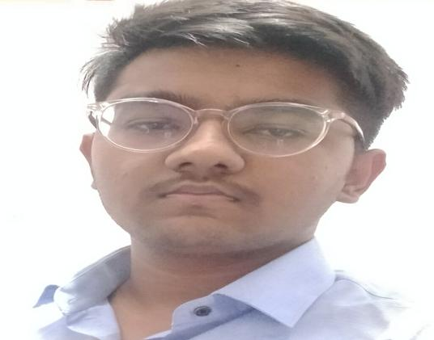

**Name: Ankit Kumar** **Age:** 21 years

~ I am a **4th year student** pursuing B**achelor of technology** in **Information Technology** from **Delhi Technological University**.

~ Recruited by **Siemens** as an **intern** from my college internship program for a period of **2 months** (29th May to 28th July).

~ I have good hands in **Coding** and have **Knowledge** about

* C++
* JAVA
* Object Oriented Programming (OOPS)
* Database Management System (DBMS)
* ML
* Web Development

~ My hobbies,

* Reading books
* Blogging



**Name: Parvesh Kumar Sirmoria** **Age:** 21 years

~ I am a **4th year student** pursuing B**achelor of technology** in **Computer Engineering** from **Delhi Technological University**.

~ Recruited by **Siemens** as an **intern** from my college internship program for a period of **2 months** (29th May to 28th July).

~ I have good hands in **Coding** and have **Knowledge** about

* C++
* JAVA
* Object Oriented Programming (OOPS)
* Database Management System (DBMS)
* Competitive Programming
* Web Development
* Cyber Forensics

~ My hobbies,

* Cricket and Chess
* Writing poems and participating in singing competition.

**What have we done in this 2 month of internship?**

**1st Month**

In first month of our internship, after the allotments and setting up of all the laptops, we all were assigned with the task of getting knowledge about the Energy IP (a product of Siemens). We were provided with some video links from Siemens Learning Cloud about Energy IP which helped us gain some knowledge and understanding about the Energy IP and the system on which we have to work.

We were also asked to have good knowledge about JAVA and its OOPS. We also learned about spring boot and Apache camel.

**2nd Month**

In the second month of our internship, we all were assigned the task of conversion of XML file to JSON file using JAVA. After the conversion, we need to map the data elements and do some modifications of the data elements. After modification we need to transfer the JSON file from the source server to the HBase and then from HBase to the destination server.

**Basic Flowchart:**

**Internship Project**

**Title:** Non-Technical Losses Analytics project

**Objective:** The project aims to build a maven project that leverage advanced data analytics, machine learning techniques, and statistical modeling to analyze vast amounts of data collected from various sources, including customer transactions, consumption patterns, billing records, and operational data.

**Requirements: -**

**Language used:** JAVA.

**File types:** XML and JSON

**IDE used:** Eclipse

**Servers used:**

**Source server:** fcypri014330.emeter.com

**HBase:** fcypri014334.emeter.com

**Destination Server:** fcypri014334.emeter.com

**Maven Dependencies and their versions used:**

1. **Camel-core (3.20.3):** Core classes for Apache Camel, an Open-Source integration framework that empowers you to quickly and easily integrate various systems consuming or producing data.
2. **Json (20230618):** The files in this package implement JSON encoders/decoders in Java. It also includes the capability to convert between JSON and XML, HTTP headers, Cookies, and CDL.
3. **Json-simple (1.1.1):** A simple Java toolkit for JSON. It uses Map and List internally for JSON processing. We can use json-simple for parsing JSON data as well as writing JSON to file. Json-simple is very lightweight API and serves well with simple JSON requirements.
4. **slf4j-log4j12 (1.7.5):** SLF4J helps with the silent switching between logging frameworks. It is simple, yet flexible, and allows for readability and performance improvements. SLF4J standardized the logging levels, which are different for the particular implementations.
5. **jackson-databind (2.15.2):** Jackson contains a set of annotations that can be used to affect the reading and writing of java objects from JSON. It is quite fast and has a low memory footprint. It is suitable for large systems.
6. **Lombok (1.18.28):** Lombok is used to reduce boilerplate code for model/data objects. It is automatically generating the getter and setter method for the class object by using Lombok annotation.

**Files and their functionality**

1. **XMLdocobj.java -**

* It has a function **finstring()** which can be utilized to convert xml document to a xml string).
* Function **finstring()** has file object with path directing to xml file.(Can be modified as per need).
* It uses xmlstring object which is created by us and has a function which accept xmldoc as an argument to return a xml string).

1. **Xmlstring.java**

* It has a method toXmlString (Document doc) which convert doc to xml string.

1. **Valdiate.json**

* It uses object of the class which has attributes of xml file.
* Json file values are stored in this object.
* Then using variables/methods of this object attributes can be displayed/validated.

1. **Fileviacamel.java**

* It uses Apache camel to create routes between system to servers.
* Configuration is needed for defining source and destination folders. Configuration has time which can be changed as per need.
* Several routes can be created with multiple destination folders pointing to different servers.
* In order to send files to server or to connect to it, ind-vpn connection is must beforehand.

1. **Output**

* This folder can be used to storing files at one place before transferring files to servers.

1. **Pom.xml**

* It is a maven project having several dependencies.